Array

1. It is a group of variables of similar data types referred to by a single element.
2. Its elements are stored in a contiguous memory location.
3. The size of the array should be mentioned while declaring it.
4. Array elements are always counted from zero (0) onward.
5. Array elements can be accessed using the position of the element in the array.
6. The array can have one or more dimensions.

An array in C/C++ or be it in any programming language is a collection of similar data items stored at contiguous memory locations and elements can be accessed randomly using indices of an array. They can be used to store the collection of primitive data types such as int, float, double, char, etc of any particular type. To add to it, an array in C/C++ can store derived data types such as structures, pointers etc.

**Why do we need Array?**

#### **Advantages:-**

* Code Optimization: we can retrieve or sort the data efficiently.
* Random access: We can get any data located at an index position.

#### **Disadvantages:-**

* Size Limit: We can store only the fixed size of elements in the array. It doesn’t grow its size at runtime.

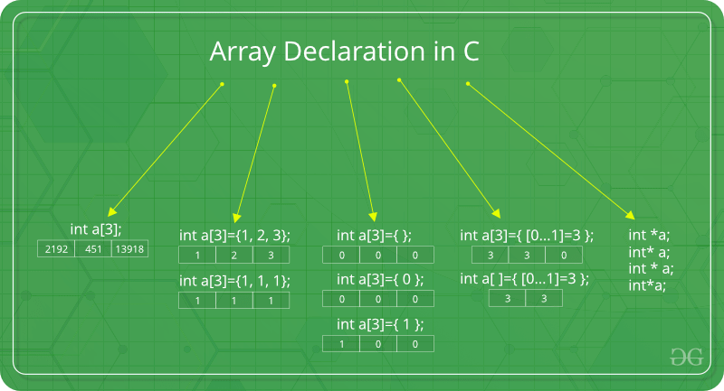

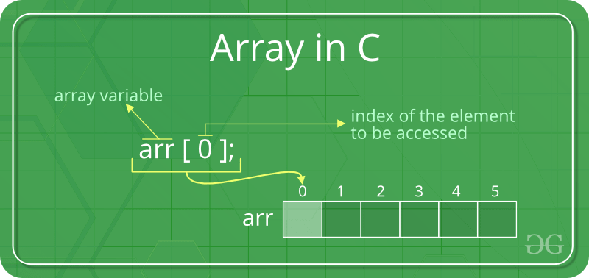

a[3][3]

| a[0][0] | a[0][1] | a[0][2] |
| --- | --- | --- |
| a[1][0] | a[1][1] | a[1][2] |
| a[2][0] | a[2][1] | a[2][2] |

Int a[10];----> garbage values

| a[0] | a[1] |  |  |  |  |  |  |  | a[9] |
| --- | --- | --- | --- | --- | --- | --- | --- | --- | --- |